Department: Computer Science Program: BS (CS)
Information Security
Announced date: |  | Due Date: |  | Total Marks = 10
Complex Computing Problem (CCP)
Mapped CLO | SDG |  | Complex Problem Solving Mapped
CLO3 | 4 |  | WP2 (Depth of analysis required)  WP3 (Depth of knowledge required)

TITLE:
CIPHERVAULT: Intelligent Secure Data Protection & Integrity Monitoring Framework

NAME
DIYA PAHOOJA

Submitted To: ALI AHMED SIDDIQUI

Abstract
Cipher Vault: Intelligent Secure Data Protection & Integrity Monitoring Framework is a comprehensive cybersecurity solution developed to ensure secure storage and transmission of digital information. The framework integrates multiple layers of security including AES encryption, RSA cryptography, SHA-256 hashing, digital signatures, user authentication, intrusion detection, and security logging.
The system encrypts user data using the Advanced Encryption Standard (AES), while RSA public-key cryptography is used for secure key management and digital signatures. SHA-256 hashing ensures data integrity by detecting unauthorized modifications. The framework also provides authentication services that restrict unauthorized access and maintains security logs for monitoring and auditing purposes.
Keywords: Cybersecurity, AES Encryption, RSA Cryptography, SHA-256, Digital Signature, Authentication, Intrusion Detection, Information Security.

Table of Contents
- Introduction
- Problem Statement
- Objectives
- Proposed Solution
- System Architecture
- Technologies Used
- Algorithms Used
- Implementation
- Testing and Results
- Performance Analysis
- Conclusion
- Future Enhancements
- References

1. Introduction
The rapid advancement of information technology has transformed the way organizations store, process, and exchange information. Businesses, governments, educational institutions, and individuals increasingly rely on digital systems for communication and data management. While these technological advancements have improved efficiency and accessibility, they have also introduced significant security challenges.
The Cipher Vault framework was developed to integrate these essential security services into a single platform. By combining AES encryption, RSA cryptography, SHA-256 hashing, digital signatures, authentication, intrusion detection, and security logging, the system provides comprehensive protection for digital information.
The project demonstrates how multiple cybersecurity technologies can work together to create a secure environment for data protection and integrity monitoring. The framework not only secures information but also provides mechanisms for detecting suspicious activities and maintaining detailed audit records.

2. Problem Statement
The increasing dependence on digital communication and electronic data storage has created significant security concerns. Organizations frequently transmit sensitive information through networks that may be vulnerable to interception, unauthorized access, or malicious modification.
Many existing systems provide only basic security features and fail to address important security requirements such as confidentiality, integrity, authenticity, and accountability simultaneously. As a result, attackers may exploit vulnerabilities to access confidential information, alter important records, or impersonate legitimate users.
Several common security problems include:
• Unauthorized access to sensitive data.
• Data tampering during transmission.
• Lack of integrity verification mechanisms.
• Absence of digital authentication.
• Insufficient monitoring and logging capabilities.
• Difficulty detecting malicious activities.
These challenges create a need for an integrated security framework capable of protecting information throughout its lifecycle. The proposed CipherVault framework addresses these problems by implementing modern cryptographic techniques and security monitoring mechanisms to ensure secure data handling and communication.

3. Objectives
The primary objective of this project is to design and implement a comprehensive cybersecurity framework that ensures confidentiality, integrity, authenticity, and accountability of digital information.
The specific objectives of the project are as follows:
- To develop a secure authentication mechanism for controlling user access.
- To implement AES encryption for protecting sensitive information from unauthorized disclosure.
- To utilize RSA cryptography for secure key exchange and digital signature generation.
- To apply SHA-256 hashing for integrity verification and tamper detection.
- To provide digital signature functionality for ensuring authenticity and non-repudiation.
- To develop an intrusion detection mechanism capable of identifying suspicious activities.
- To maintain detailed security logs for monitoring and auditing purposes.
- To analyze system performance and evaluate the effectiveness of implemented security mechanisms.
- To demonstrate practical applications of cryptographic techniques in modern cybersecurity systems.
- To provide a scalable foundation for future enhancements and enterprise deployment.

4. Proposed Solution

4.1 Overview
The proposed solution, CipherVault: Intelligent Secure Data Protection & Integrity Monitoring Framework, is designed to provide a comprehensive security environment for protecting sensitive digital information. The framework integrates multiple cybersecurity mechanisms into a unified platform to ensure confidentiality, integrity, authenticity, and accountability.
Unlike traditional systems that rely on a single security layer, CipherVault employs multiple cryptographic techniques and monitoring components. The framework combines authentication, encryption, digital signatures, hashing, intrusion detection, and security logging to create a secure ecosystem for data protection.
The system is capable of encrypting messages and files, generating secure cryptographic keys, verifying data integrity, detecting unauthorized modifications, and maintaining security audit records.

4.2 System Workflow
The operational workflow of CipherVault is illustrated below:
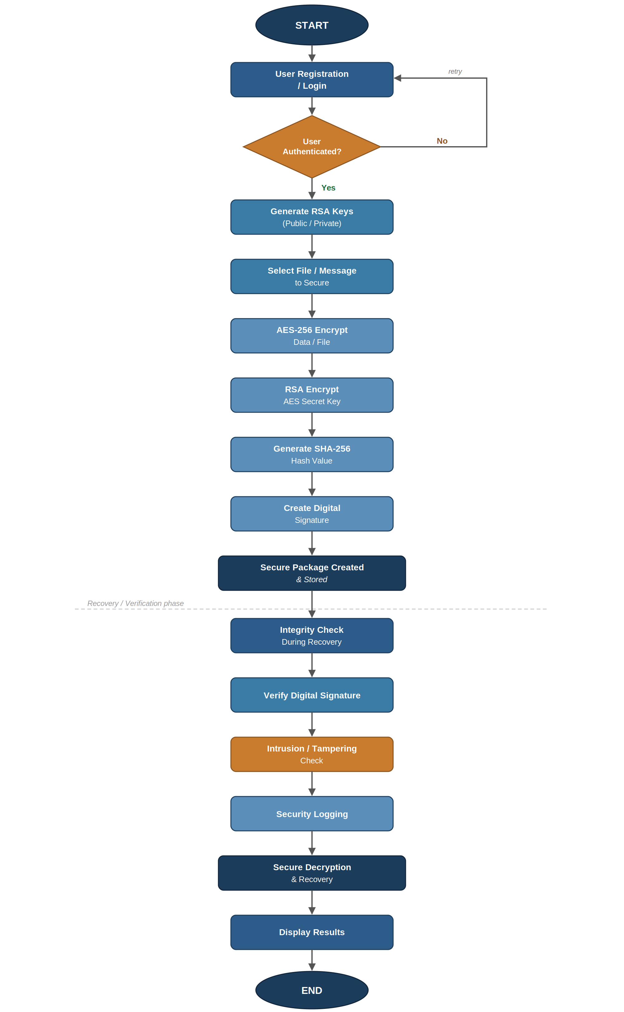
4.3 Security Layers
CipherVault implements the following security layers:

Layer 1: Authentication
Ensures only authorized users can access system resources.

Layer 2: Encryption
Protects data confidentiality using AES encryption.

Layer 3: Key Protection
Uses RSA public-key cryptography for secure key management.

Layer 4: Integrity Verification
Employs SHA-256 hashing to detect unauthorized modifications.

Layer 5: Digital Signature
Verifies authenticity and prevents repudiation.

Layer 6: Intrusion Detection
Monitors activities and detects suspicious behavior.

Layer 7: Security Logging

5. System Architecture
CipherVault follows a modular architecture where each security component operates independently while communicating with other modules through controlled interfaces.
This design improves maintainability, scalability, and reliability.
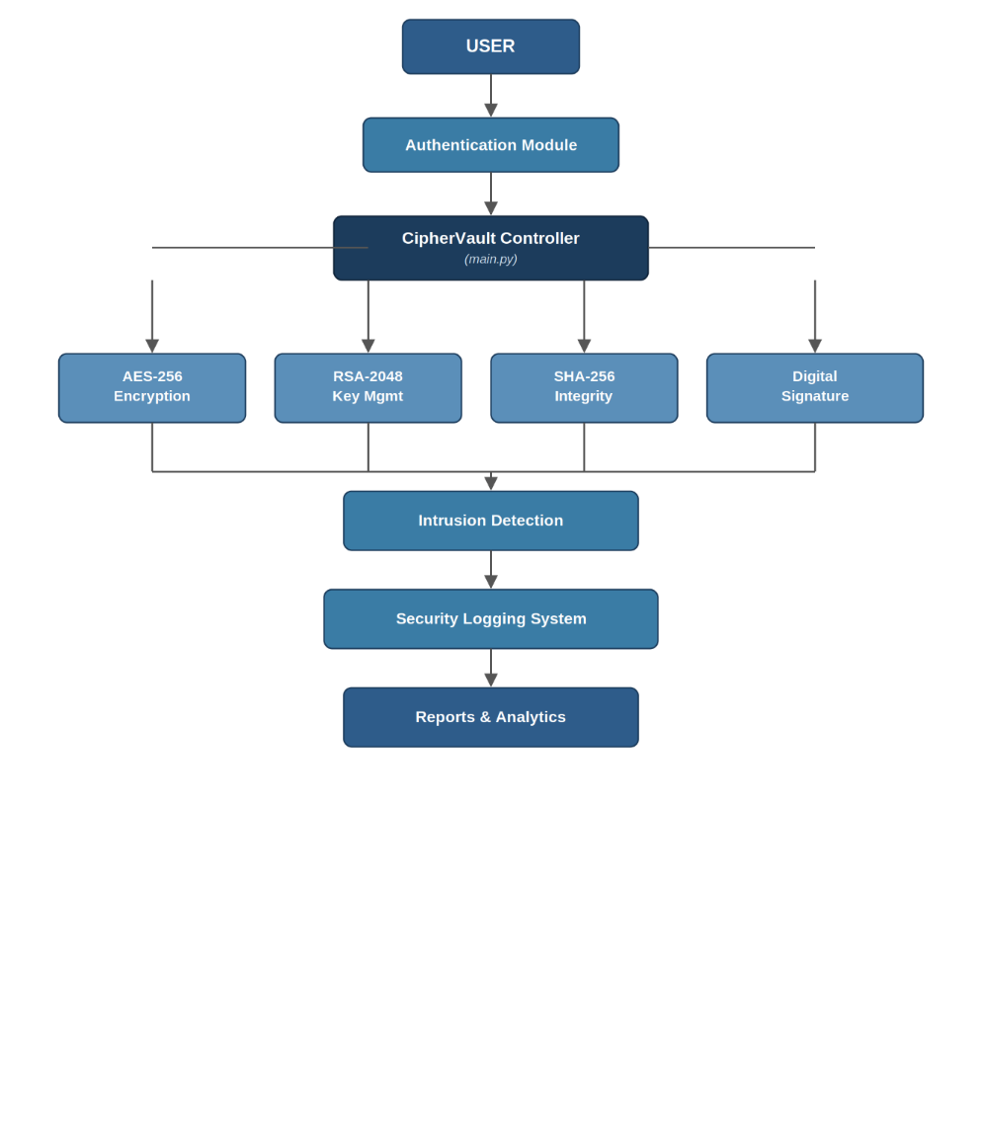
5.1 CipherVault Architecture Diagram:

Main Menu
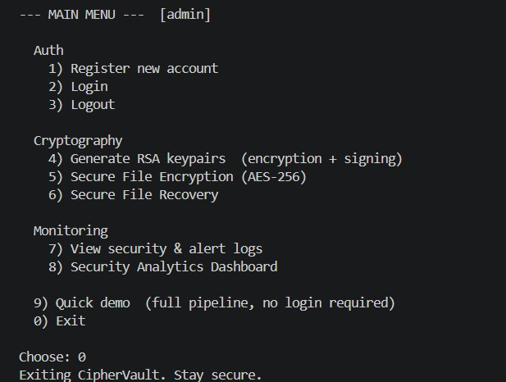
5.2 Authentication Module
The Authentication Module manages user registration and login operations.
Responsibilities:
• User registration
• User verification
• Password validation
• Session management

Benefits:
• Prevents unauthorized access
• Restricts system usage to legitimate users
Registration Output
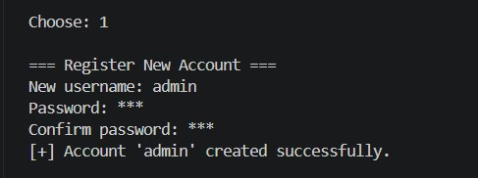
Login Output
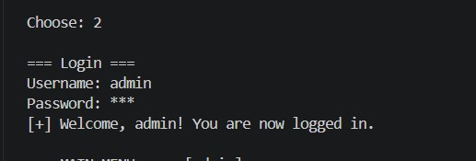

5.3 Cryptography Module
The Cryptography Module is responsible for encryption, decryption, and key management.
Main Functions:
• AES encryption
• AES decryption
• RSA key generation
• RSA key protection
Benefits:
• Confidentiality
• Secure communication
• Strong protection against attackers
RSA Key Generation
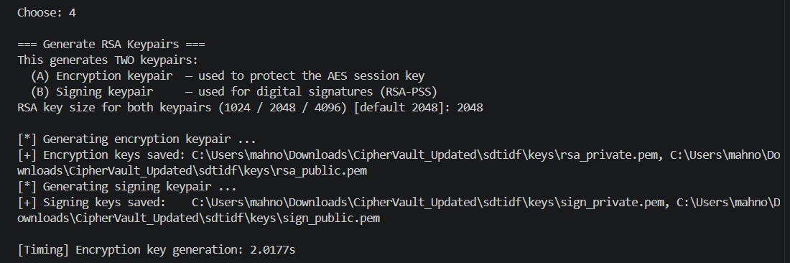
Encryption Output
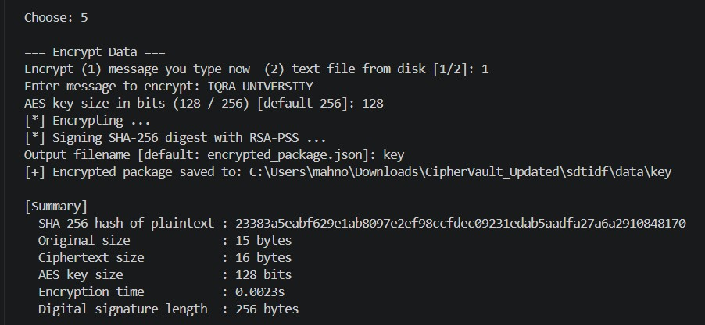
Decryption Output
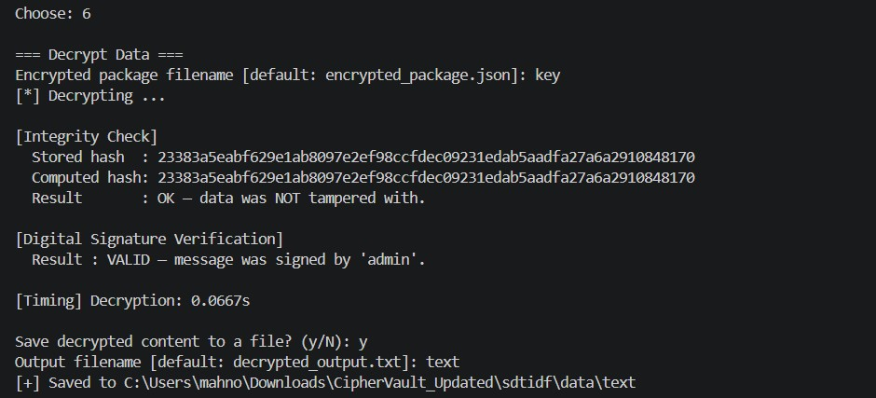

5.4 Integrity Verification Module
This module verifies that information remains unchanged during storage or transmission.
The SHA-256 algorithm generates a unique hash value for each data block.
If data changes:
Original Hash ≠ New Hash
Therefore:
Integrity Failure Detected
Benefits:
• Tamper detection
• Data validation
• Enhanced reliability
Integrity Verification Success
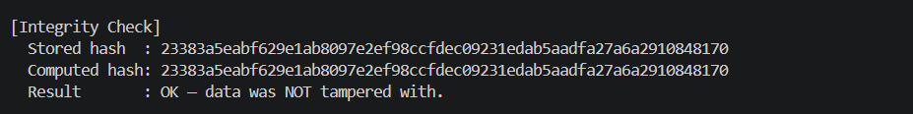

5.5 Digital Signature Module
The Digital Signature Module verifies the authenticity of data.
The sender signs information using a private key.
The receiver verifies the signature using a public key.
Benefits:
• Authenticity
• Non-repudiation
• Integrity assurance

Digital Signature Verification
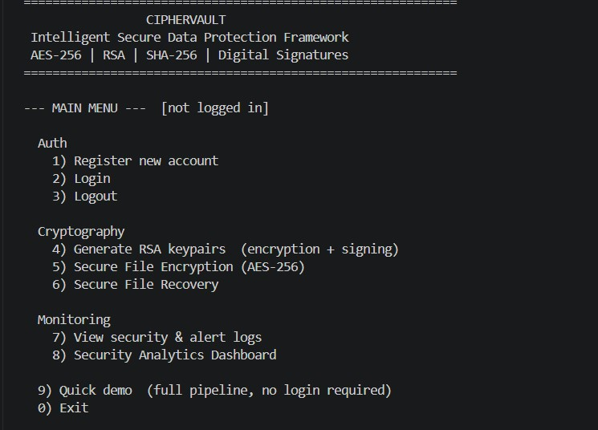

5.6 Intrusion Detection Module
The Intrusion Detection Module continuously monitors security events and system activities.
Responsibilities:
• Detect suspicious activities
• Monitor security violations
• Generate alerts
Benefits:
• Early threat detection
• Enhanced monitoring
• Security awareness
Intrusion Detection Output


5.7 Security Logging Module
The Security Logging Module records important security events.
Examples:
• Login attempts
• Encryption operations
• Decryption operations
• Signature verification
• Intrusion alerts
Benefits:
• Auditing
• Accountability
• Forensic investigation
Security Logs
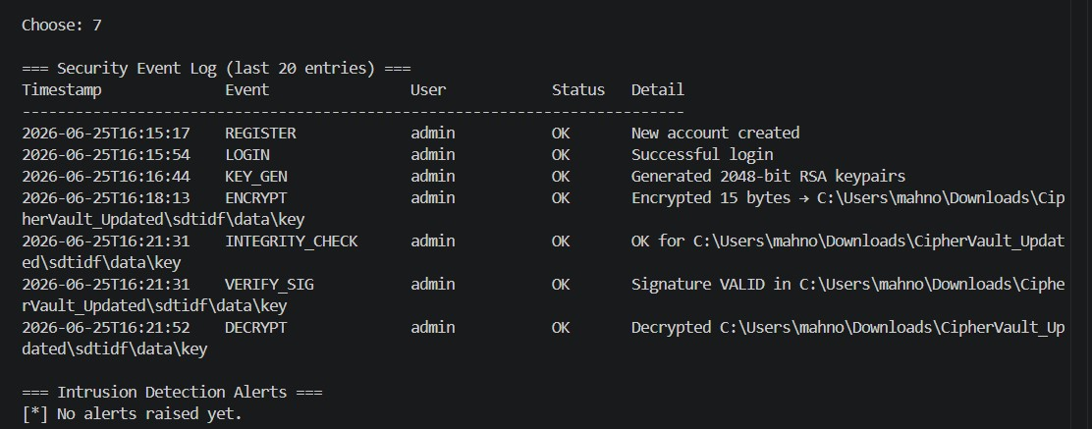

6. Technologies Used
Programming Language: Python 3
Libraries:
• Cryptography
• PyCryptodome
• hashlib
• json
• os
• logging
Development Environment: Visual Studio Code
Operating System: Windows 11

7. Algorithms Used

AES Algorithm
Input: Plaintext
Output: Ciphertext
Advantages:
• Fast
• Secure
• Industry Standard

RSA Algorithm
Used for:
• Key Exchange
• Digital Signatures
Advantages:
• Strong Security
• Public Key Infrastructure

SHA-256 Algorithm
Used for:
• Integrity Verification
Advantages:
• Collision Resistant
• One-Way Hash Function
8. Implementation
Explain each Python module:
main.py Main system controller
auth.py Authentication management
crypto_utils.py AES, RSA, SHA-256 implementation
digital_signature.py Digital signature generation and verification
intrusion_detection.py Tamper detection
security_logger.py Security event logging
performance_analysis.py Performance monitoring

9. Testing and Results
Test Case 1: Encryption
Result: Pass
Test Case 2: Decryption
Result: Pass
Test Case 3: Integrity Verification
Result: Pass
Test Case 4: Digital Signature Verification
Result: Pass
Test Case 5: Authentication
Result: Pass
Test Case 6: Intrusion Detection

Quick Demo Output
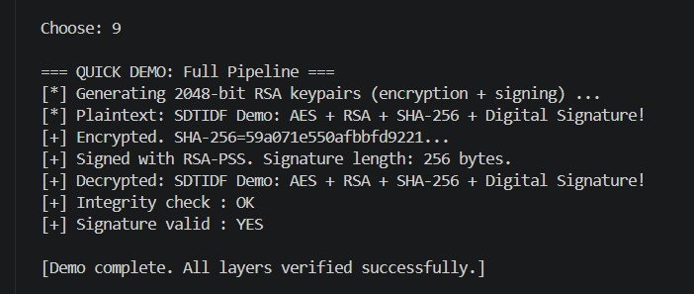

10. Performance Analysis
Performance Analysis Dashboard
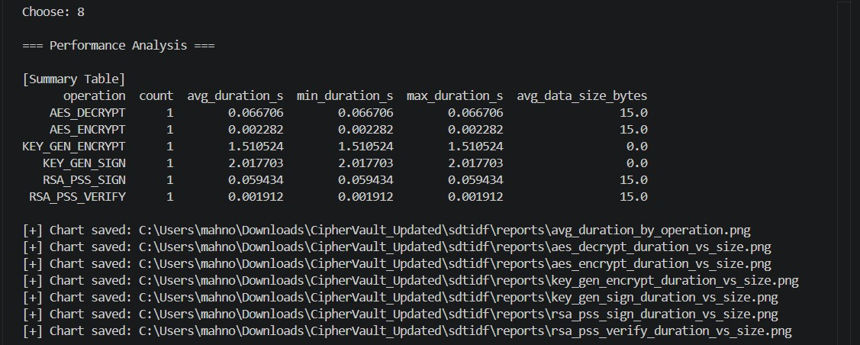
Discuss:
• Encryption Time
• Decryption Time
• Signature Verification Time

11. Conclusion
CipherVault successfully integrates multiple cybersecurity techniques into a unified framework. The system ensures confidentiality, integrity, authenticity, and monitoring of digital information.
The project demonstrates practical application of cryptography and secure computing concepts while providing an effective solution for protecting sensitive information.

12. Future Enhancements
• Graphical User Interface
• Cloud Storage Integration
• Multi-Factor Authentication
• Real-Time Threat Detection
• AI-Based Intrusion Detection
• Secure Enterprise Deployment

13. References
AES Standard
RSA Cryptography Documentation
SHA-256 Documentation
Python Cryptography Documentation

